Online Application Guidance

Step1: Open the online application website: www.studyatpku.com/member/login.do



Step2: register an account and sign in.

Step3: Click on "Online Application"
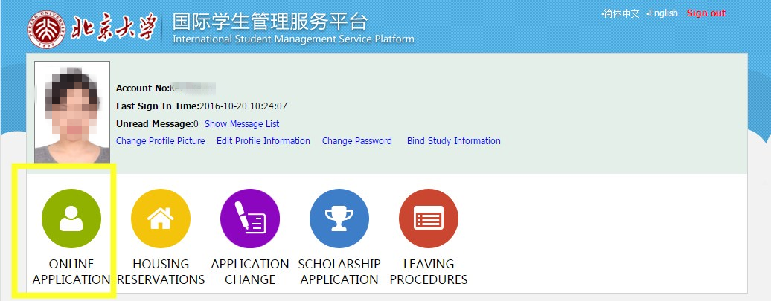

Step4: Click on 'Application' column, then choose 'Non-Degree Programs Application' and click "Next".
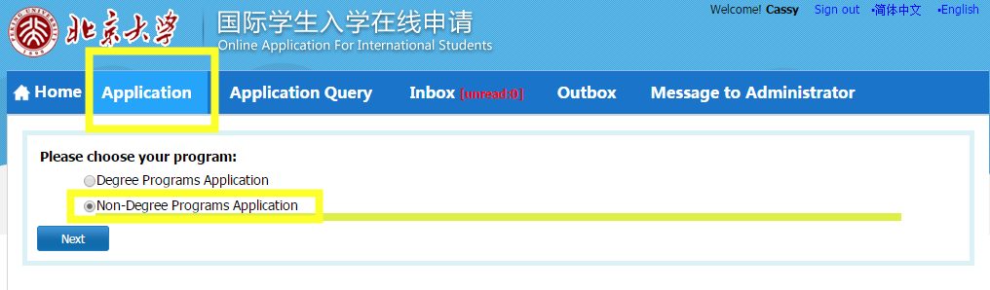

Step5: choose the 'College Program（ST2）' from 'Short-term Program(ST)', then click 'Next'.
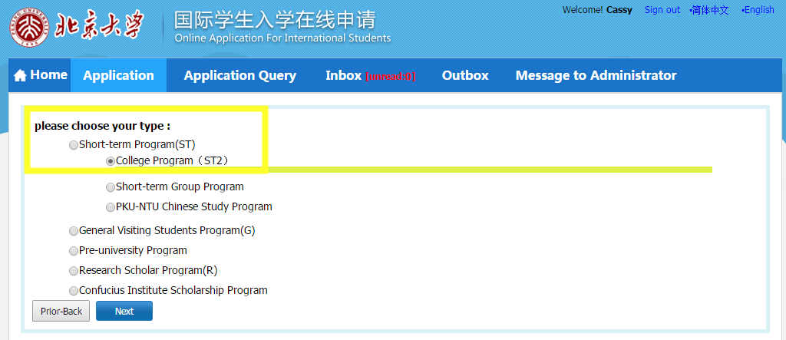

Step6: Choose “Business Chinese Program, School of Chinese as a second Language, Peking University” and click on ‘Apply’
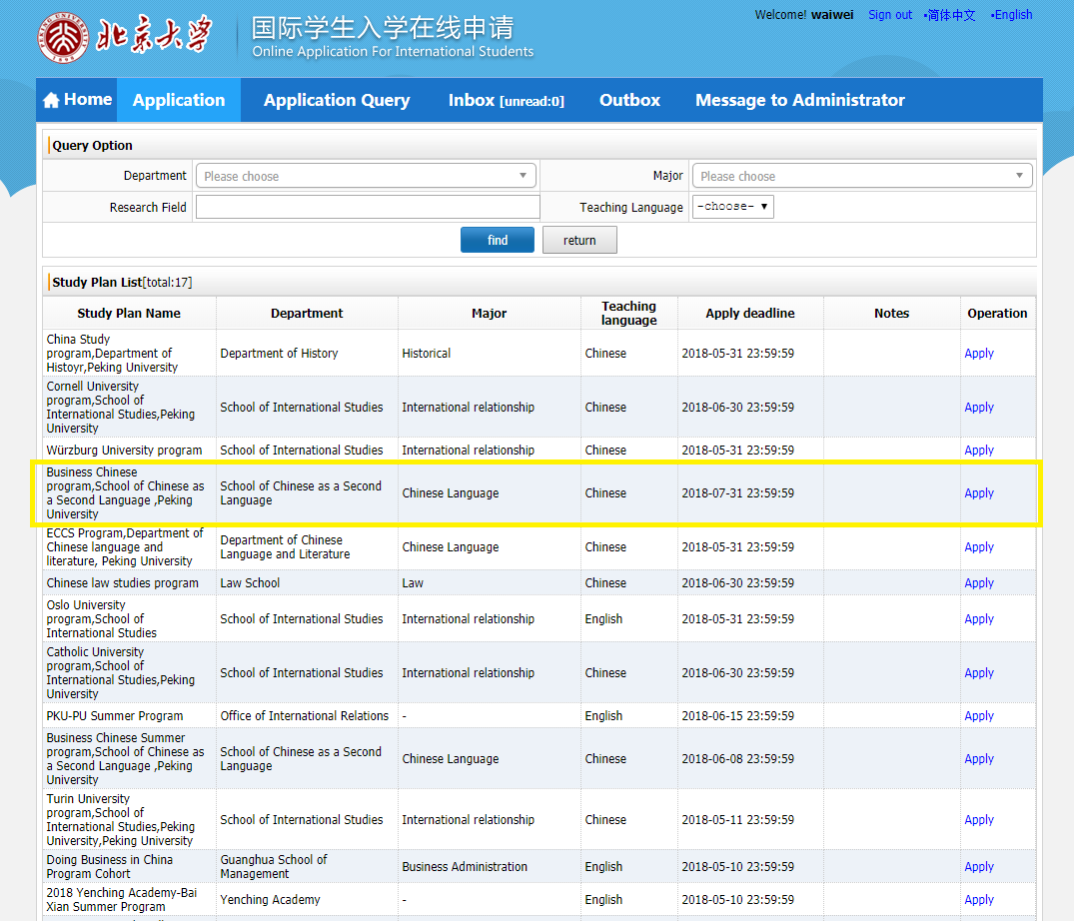

Step7: fill in all the information on the application form.
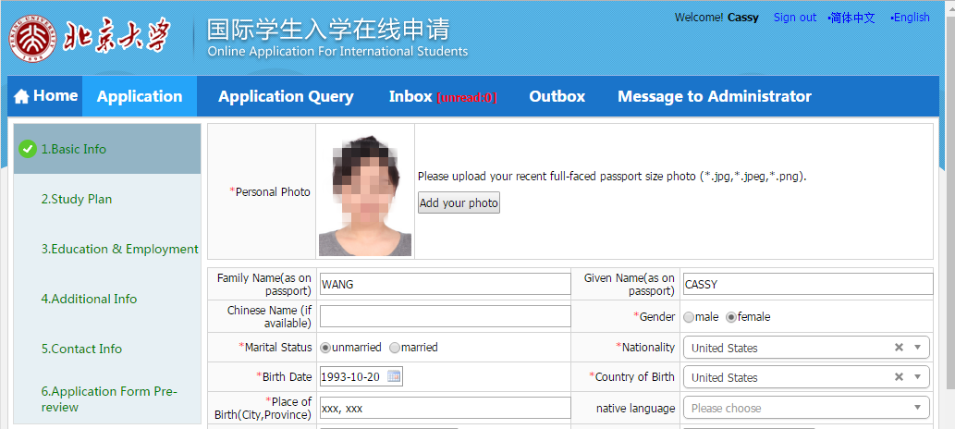

Step8: After the completion of registration, click on 'Submit' to submit your application.
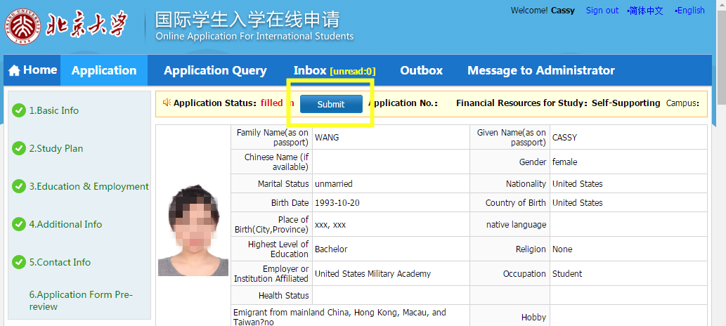

Step 9: Click on 'Download Application Form' to download your application form.
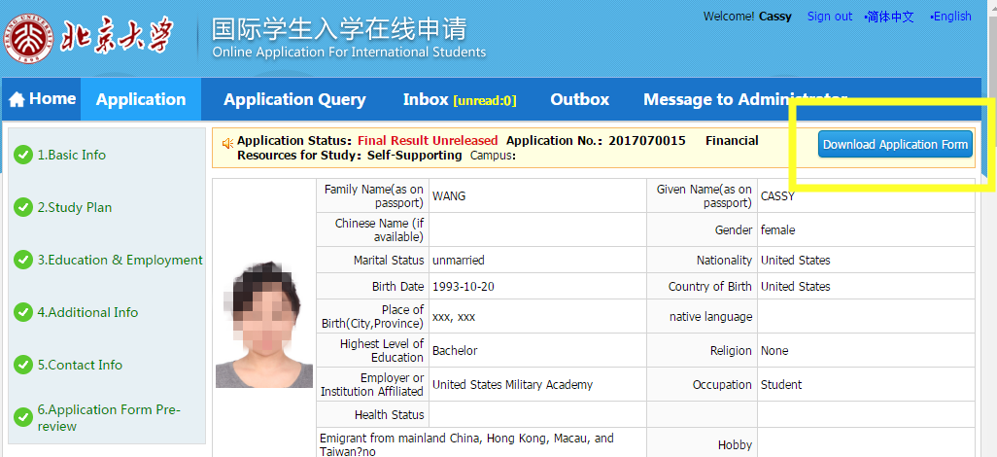

Step 10: Send your Application Form to ghxzs@pku.edu.cn

